Registration Quick Reference Card for Employees/Associates

Contents
Registration 2
Activate Your Email Address 6
Activate Your Mobile Phone 6
Forgot Your User ID/Password? 7

Registration
Welcome! ADP is committed to protecting your privacy and ensuring that only you can access your personal information. To assist us in meeting that commitment, you must register with us before using our services.
You will need your registration code ERHomes-12345 and the URL of your ADP service web site.
On your ADP service web site, click the link to register for ADP services.
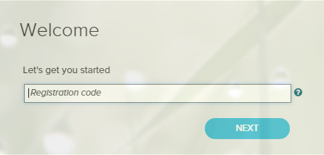
Enter your registration code.
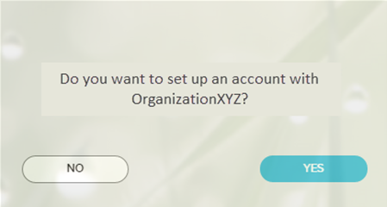
If you do not recognize the name of your organization, select No and start over.

Enter your information to help us find you in our records.
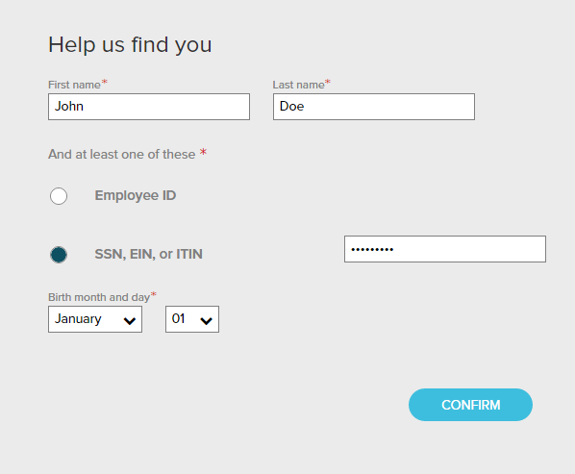
The options available on this page might vary based on your organization’s setup.
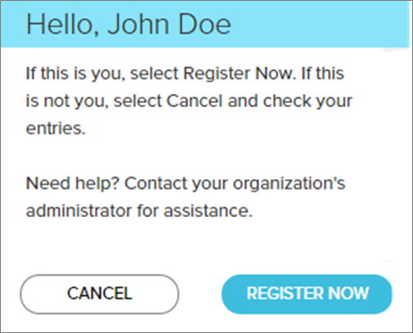
Click REGISTER NOW.

Complete the page and click REGISTER NOW.
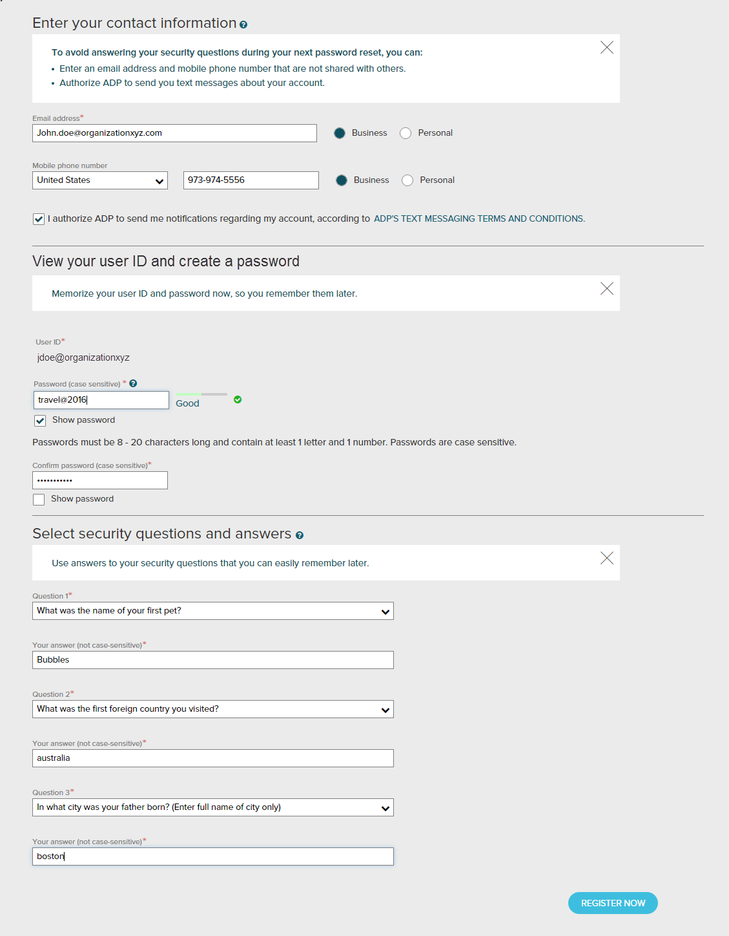
Depending on the ADP services your organization has purchased, the option to create your user ID might be available.
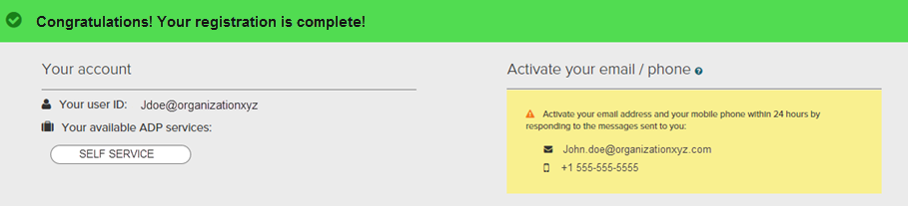
Your registration is complete. You can use your user ID and password to access your ADP service(s).
- Activate your email and mobile phone number to receive important notifications from your organization or ADP.
- Manage your account information to keep it accurate.

Activate Your Email Address
During registration, if you provided an email address that is not shared with others in your organization, look out for an activation email from ADP. Click the link in the email you receive from SecurityService_NoReply@ADP.com to complete the activation.
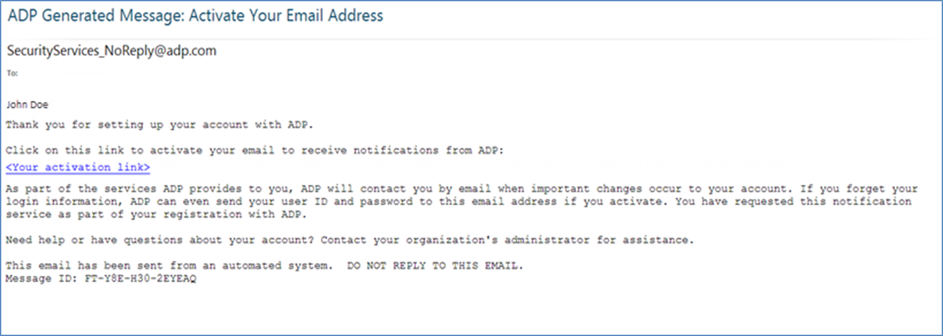

Activate Your Mobile Phone
During registration, if you provided a mobile phone number that is not shared with other users in your organization, look out for a text message from ADP. Reply with the code or follow the instructions in the text message to activate your mobile number. In the United States, the message will come from sender “90206”; the sender will vary in other countries.
Note: In some countries, this texting method to activate your mobile phone is not available, so your activation process will differ. Follow the instructions on the confirmation page and in the activation email you receive from ADP to complete the activation.
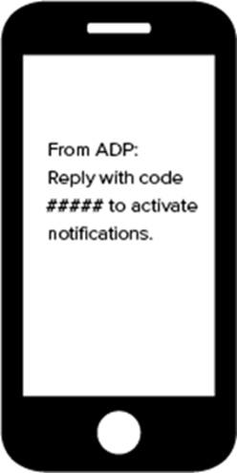

Forgot Your User ID/Password?
If you forget your login information, you can use the “Forgot Your User ID/Password?” link on your ADP service web site to retrieve your user ID and reset your password. During this process, you will be required to verify that you are the rightful owner of the account to protect your personal information.
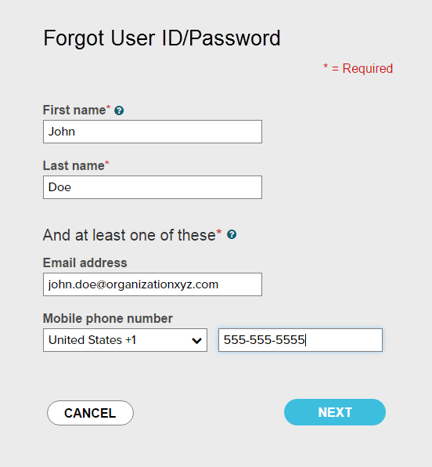
Enter your first name and last name exactly as they exist in your organization’s records.

Enter an email address and/or mobile phone number associated with your account.
Upon successful verification of the information that you entered, your user ID will be displayed.
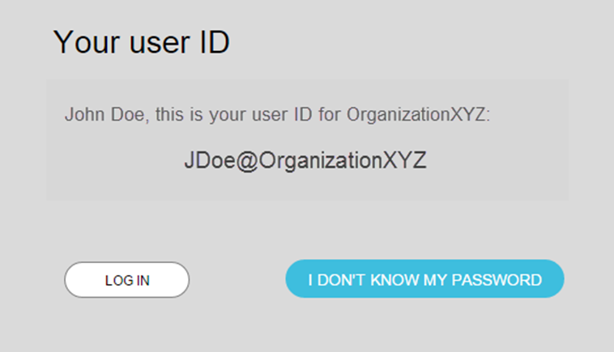
Click I DON’T KNOW MY PASSWORD to reset your account password.

The process will be different for administrators / practitioners.
Congratulations! You have successfully retrieved your user ID of your ADP service account.

To Reset Your Password
Select the “I don’t know my password” option. If you have an email address and/or mobile phone number that is not shared with others in your organization, you can receive and enter a security code.
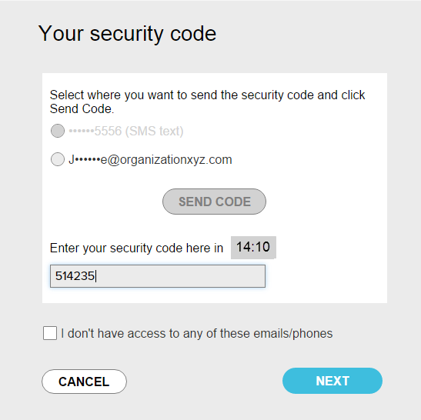
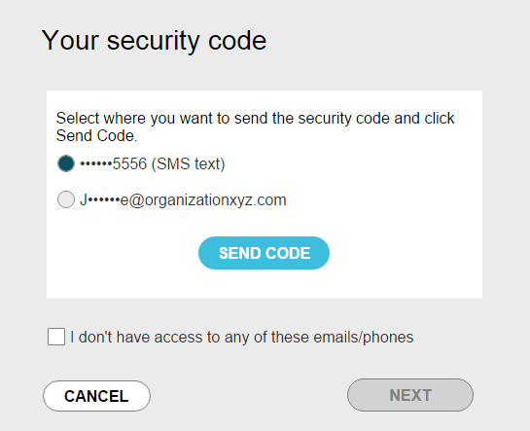
…and enter it here within 15 minutes.
Send the code to your email or mobile phone…
If you don’t have access to your email/phone or you share your email address and/or mobile phone number with others in your organization, you will be prompted to answer security questions instead.
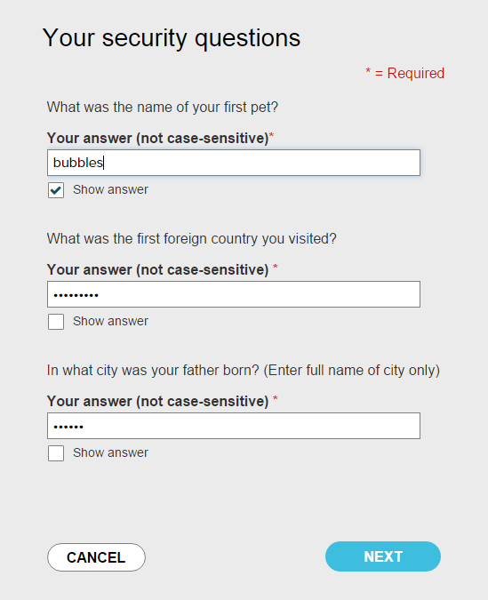
Click Show answer to reveal your answer briefly.
Upon successful verification of your security code or your security answers, you will be prompted to enter and confirm your new password.
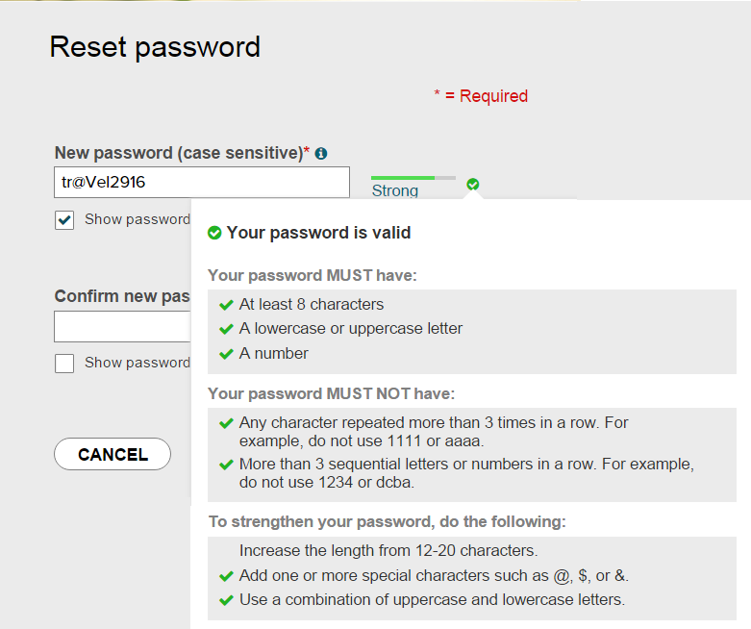
Click to see how well your password meets the requirements and how to make it stronger.
Click Show password to reveal your password briefly.
Congratulations! You have successfully retrieved your user ID and reset your password of your ADP service account.

